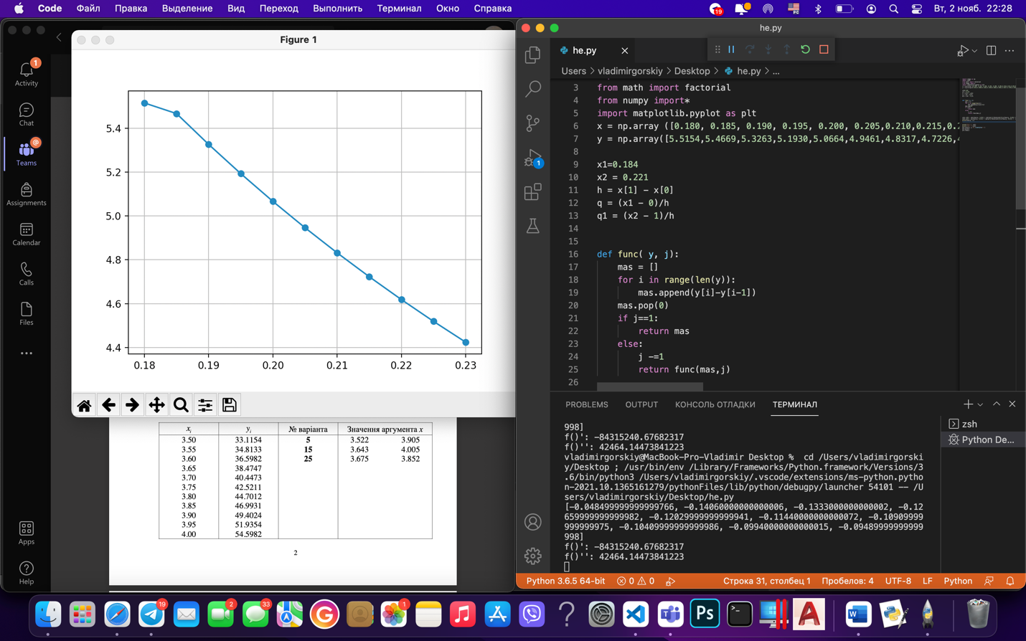import numpy as np

import math

from math import factorial

from numpy import\*

import matplotlib.pyplot as plt

x = np.array ([0.180, 0.185, 0.190, 0.195, 0.200, 0.205,0.210,0.215,0.220,0.225,0.230])

y = np.array([5.5154,5.4669,5.3263,5.1930,5.0664,4.9461,4.8317,4.7226,4.6185,4.5191,4.4242])

print(‘variant 4’)

x1=0.184

x2 = 0.221

h = x[1] - x[0]

q = (x1 - 0)/h

q1 = (x2 - 1)/h

def func( y, j):

mas = []

for i in range(len(y)):

mas.append(y[i]-y[i-1])

mas.pop(0)

if j==1:

return mas

else:

j -=1

return func(mas,j)

yx1= y[0] - q1\*(func(y, 1)[0]) + (q1\*(q1-1)/factorial(2))\*(func(y, 2)[0]) + (q1\*(q1-1)\*(q1-2)/factorial(3))\*(func(y, 3)[0])+(q1\*(q1-1)\*(q1-2)\*(q1-4)/factorial(4))\*(func(y, 4)[0])+(q1\*(q1-1)\*(q1-2)\*(q1-3)\*(q1-4)/factorial(5))\*(func(y, 5)[0])

yx2= y[5] - q\*(func(y, 1)[4]) + (q\*(q-1)/factorial(2))\*(func(y, 2)[3]) + (q\*(q-1)\*(q-2)/factorial(3))\*(func(y, 3)[2])+(q\*(q-1)\*(q-2)\*(q-4)/factorial(4))\*(func(y, 4)[1])+(q\*(q-1)\*(q-2)\*(q-3)\*(q-4)/factorial(5))\*(func(y, 5)[0])

print(func(y, 1))

print("f()':", yx1)

print("f()'':",yx2)

plt.plot(x, y,'o',linestyle='-')

plt.grid()

plt.show()